**Assignment: Jenkins Job with parameters**

1. **Simple echo command with parameter**

Create a freestyle project, name it whatever you like.

In your project, create one string parameter named “message.”

In your project, create a build step that is “execute Windows batch command”.

In this step, execute an echo command that prints out the message from the message parameter.

Save the project.

Run your job with a message in the parameter field. If it fails, troubleshoot the issues.

Please send a screenshot of the output of a successful job run.

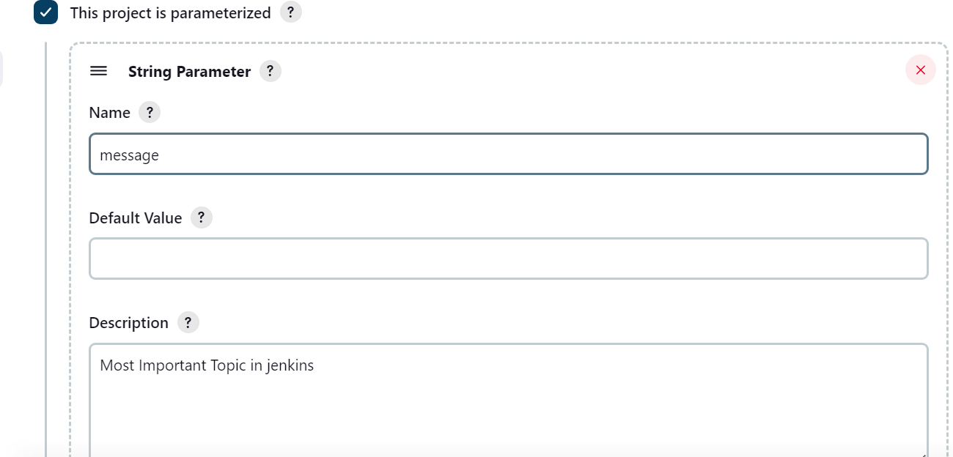

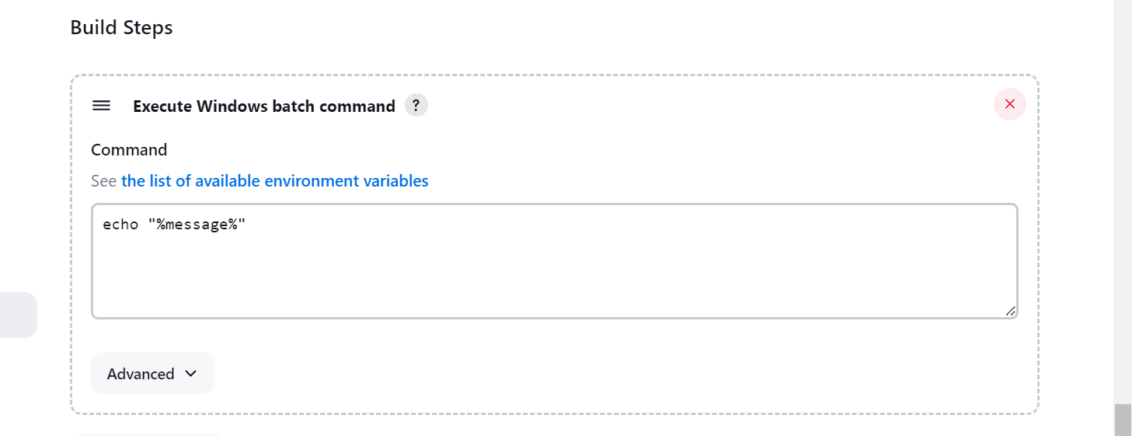

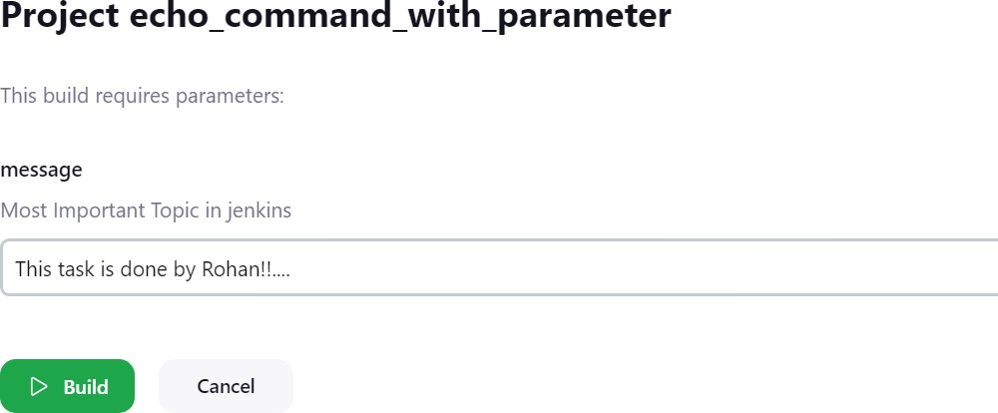

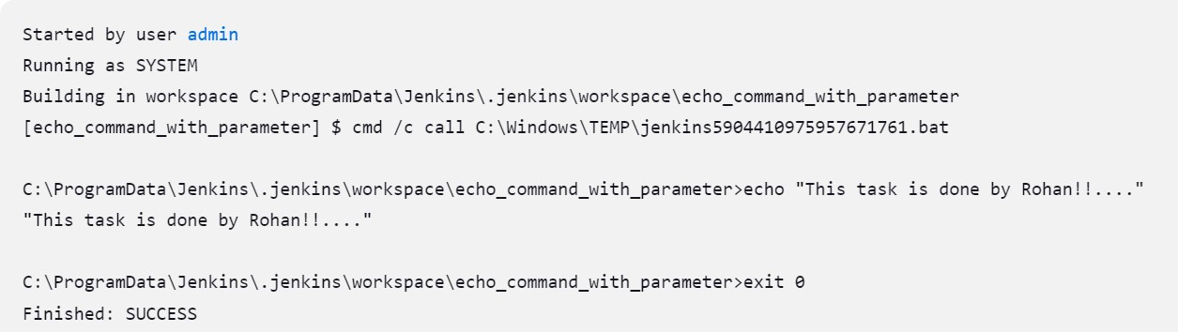

2. Create a script that does the following:

* The script should use the argparse module to handle command line arguments.
* The user should provide a message using the -m or --message option.
* If a message is not provided, the script should display an error message and show the usage instructions.
* If a message is provided, the script should print it to the screen.

Afterwards, create a Jenkins job that does the following:

Create a freestyle project, name it whatever you like.

In your project, create one string parameter named “message.”

In your project, create a build step that is “execute Windows batch command”.

In this step, execute the python script you just made with the message option using the message parameter.

Save the project.

Run your job with a message in the parameter field. If it fails, troubleshoot the issues.

Please send a screenshot of the output of a successful job run.



